Explanatory Preface

This article is written in the style of the New York Times reporting on the study “Economic sanctions and HIV/AIDS in women” by Yiyeon Kim and published in The Journal of Public Health Policy. It follows the short, but plentiful paragraph style that the NYT adopts. Images are used with some regularity, and sourced underneath. References within the article itself mimic the hyperlink style seen in other NYT articles. A left leaning political bias was also implemented, which is common within NYT articles.

HEALTH

The Human Cost of Economic Sanctions
A new study connects a rise in the HIV/AIDS epidemic to US policies, linking economic sanctions to an increase in infection rates in women in target countries.

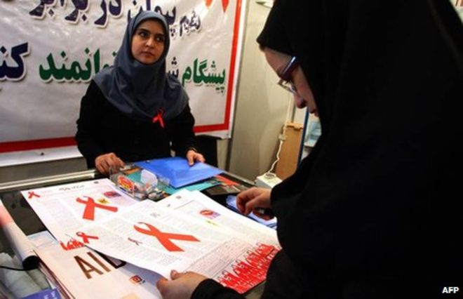
An Iranian woman educates the public about HIV in an attempt to decrease stigma around the disease within the community (BBC Image Source)

By Erin O’Reilly

September 18, 2019

Early last Saturday morning in eastern Saudi Arabia, loud explosions broke the night sky. A crucial oil processing center was attacked, and the explosions spurred fires that lasted well past morning light. The unprecedented strike proved to be a devastating hit to the nation’s oil operations and has sent a resulting surge of fear across the globe.

President Trump was quick to place blame on Iran, despite Tehran’s insistence to the contrary. The emotive President has also not been quiet about his desire to place even harsher sanctions on Iran in response to the attack, tweeting off aggressive rhetoric concluding that the US is “locked and loaded” to respond.

Trump’s tumultuous tenure has been marked by unforgiving international relations and inflammatory response, and it’s likely that this most recent tiff with Iran will be no different. An increase in economic sanctions on Iran, however, will do more than simply injure the national defense budget. The most vulnerable groups will be crippled by Trump’s latest attempt to poke the bear that is Iran. Economic sanctions often fail to reach the harm intended by their insinuators, and instead attack most greatly the marginalized populations, such as women, who a new study finds are more susceptible to HIV infection when living under economic sanctions.

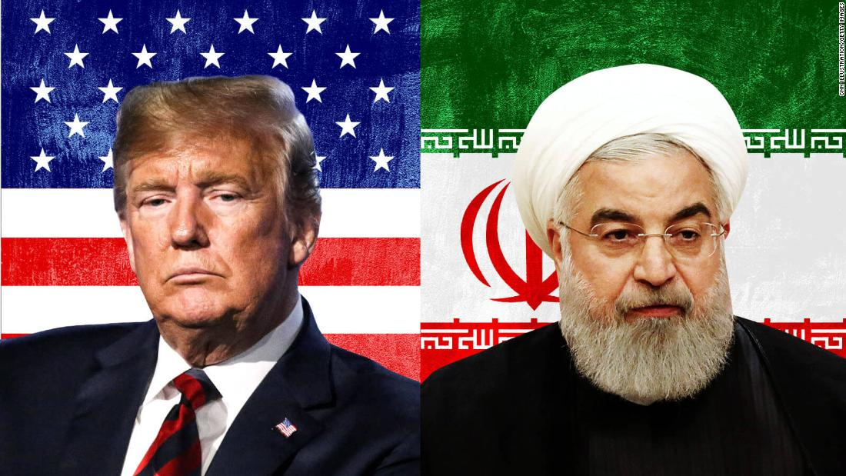
United States President Trump and Iranian President Hassan Rouhani (Washington Post Source)

The recently published study in The Journal of Public Health Policy finds that rates of human immunodeficiency virus (HIV) in women spike when under economic sanctions due to decreased participation in the labor force. Researcher Yiyeon Kim emphasizes that ripples extending from these sanctions are much farther reaching and longer lasting than we may realize, and that policy makers such as President Trump, must fully understand the real impact of their decisions before implementing them.

Kim explores data from 84 different countries across Asia, Africa, and Latin American, where an astonishing 90% of the world’s HIV population lives. The study follows a time period of 1990 – 2012, including the US’s sanctions on Iran up through President Obama’s first term in office.

The study is broken down into three parts: 1) the direct impact of sanctions on HIV infection rates, 2) the effect of sanctions on female employment, and 3) the relationship between female employment and HIV infection rates. Kim has found significant evidence of association in all three cases. A fixed effects regression analysis was preformed, which creates an estimated model of the relationship between two variables whilst allowing control over others such as level of democracy, GDP, and urbanization. This model allowed Kim to verify correlation in all three parts of her study.

Women are disproportionally affected by HIV world-wide. Not only do they make up more than half of the world’s infected, but young women between the ages of 15 and 24 are twice as likely to be infected by HIV than their male counterparts. Kim argues that this remains due to the fact that females are simply a more vulnerable gender in too much of the world. Domestic violence, inadequate or lack of access to healthcare, and overall inequality all contribute to the increased susceptibility of the female population to HIV.

The epidemic has genuinely become one characterized by women, even taking the crown as leading cause of death in women of reproductive age. The virus is not to be taken lightly, and in many of these cases is a death sentence, and as such this proposed relationship between sanctions and increased rates of infection is one to be carefully considered.

Kim further highlights the dissymmetry with which women lose their jobs in times of economic crises as compared to men. In economic distress, women are also more susceptible to prostitution and other forms of transactional sex work in order to survive and provide. This kind of risky sexual behavior drives up rates of HIV infection within the population.

Across the time periods of sanction studied, Iran reduced its budget for HIV prevention and treatment to almost zero. Lacking a safe-sex and HIV prevention education program, rates increased, and minimal treatment programs were in place to slow the rising epidemic.

The country is now facing it’s harshest sanctions to date, with the Iranian President refusing to negotiate with an “enemy who uses sanction and poverty as a tool”. At this point it’s not a question of if, but when will we start to see rates rise, and if we will we be too late to help them.

The government is fast to defend its sanctions in the name of the protection of peace and human rights. But what if these sanctions are causing more harm than good? This is not strictly a Trump-era phenomenon, and this is not something restricted to our relationship Iran. This issue falls to both sides of the aisle to understand and fix. Economic sanction policy has always fallen victim to criticism, and this is simply one more tool for reform towards better foreign policy and a happier, healthier world.

